School Waste  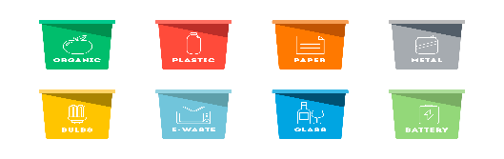  This Photo by Unknown Author is licensed under CC BY-NC | Action  - Conduct a waste audit using Resource Futures  - Provide waste food caddies for the EYFS, staff room, school kitchen and playgrounds.  - Provide sacks/bins for paper, card, plastic etc in classrooms, office  - ‘Check it before you chuck it’ - sign and label recycling points in classrooms, staff room, kitchen. | Duration  - Sept – December 2025 Autumn Term focus – bring food waste caddies into school  - Spring Term Focus – “Check it before you chuck it” – reduce contamination or rubbish in the wrong place (other things which COULD be recycled: food waste, tetrapak, plastics etc)  - Summer Term Focus – packed lunch waste  - Autumn ’26 – review progress and next steps
Aim  - Eliminate food waste in classroom and playground bins which is going into general waste  - Reduce amount of food waste  - Ensure all rubbish which can be recycled is being recycled    Litter | Informing & Involving Plans  - Eco rangers to be involved in auditing school waste  - Eco rangers to run a whole school assembly and to take on responsibility for emptying and cleaning caddies (supervised by SR as required)  - All children to be involved in designing and creating posters for the ‘check before you chuck’ and campaign.  Duration - September 2025 – July 2026 | Monitoring & Evaluation  - Eco Rangers to do regular monitoring walks around the school  - Eco Rangers to collect and clean food waste caddies and ensure clean sites  - Eco Rangers to monitor classroom bins and recycling points  - Waste to be discussed at School Council meetings throughout the year  - Audit to be repeated end of year  Monitoring Method  - SR to monitor litter around the school  - School governor involvement in monitoring? Pupil voice? Updates on newsletters?
Aims  - The school and playgrounds, are kept litter free.  - Children take pride in their school and share responsibility for keeping them clean and litter free  - Children are encouraged to be advocates for positive change in the community through participation in a community litter picking event. | Action  - Buy litter pickers  - Appoint Eco Rangers (September 2025 – July 2026)  - Monitoring Method. SR to set up ‘litter picking’ timetable for Eco Rangers to patrol and monitor litter  - The school is kept litter free. Children take pride in their school and share responsibility for keeping them clean and litter free.  - Children are encouraged to be advocates for positive change in the community through a community litter picking event.  - Organise school litter picking activity around the village | Informing & Involving Plans  - Children appointed as Eco Rangers  - School-wide litter picking event  - Community litter picking event  - Children to design anti-litter campaign posters and social media publications to support the litter picking events and anti-litter campaign

